TRÉSOR
Customer Segmentation & Intelligence AI
Retail Banking — Project Documentation
By :
Naveen 23BCE1579
Adhya Sharma 23BAI1280

1. Introduction & Problem Statement
TRÉSOR is an AI-powered customer intelligence agent built for retail banking. It lets a bank's analytics or marketing team simply type a question in plain English into a chat box and get back a data-driven answer — without writing SQL, without opening a BI dashboard, and without waiting on a data analyst.
A retail bank offers savings accounts, credit cards, personal loans, and investment products, but currently applies broad, one-size-fits-all marketing — the same email goes to a customer who spends heavily every month and to one who's been inactive for six months. This leads to low engagement and weak product adoption. The bank wants to use its own customer data to understand behavioral patterns, segment customers into meaningful groups, and deliver personalized recommendations.

Objective
TRÉSOR is designed to:
- Perform automated Exploratory Data Analysis (EDA) on customer data.
- Segment customers by behavioral and financial attributes.
- Generate interpretable, human-readable customer personas.
- Recommend personalized banking products/strategies per segment.
- Produce human-readable insights and summaries instead of raw numbers.
- Simulate how a bank's analytics team would derive insights, with minimal manual intervention.
Minimum functional requirements covered: a natural-language chat interface, dynamic EDA, rule-based segmentation, explainability (why a customer belongs to a segment), and human-readable summarization — all driven from one conversational entry point.

Dataset
- Source: Kaggle — "Credit Card Dataset for Clustering" (CC_GENERAL.csv).
- ~9,000 active credit card holders, tracked over a 6-month evaluation period.
- 18 behavioral variables per customer (balance, purchases, credit limit, payments, tenure, etc.), loaded into a live MySQL table (cc_general).

2. System Architecture
TRÉSOR is built as an n8n agent pipeline — a visual, node-based workflow rather than a hand-coded multi-agent framework. Each node has exactly one job, and data flows in a straight, inspectable line: user question → routing decision → database query → filtered payload → plain-English answer.
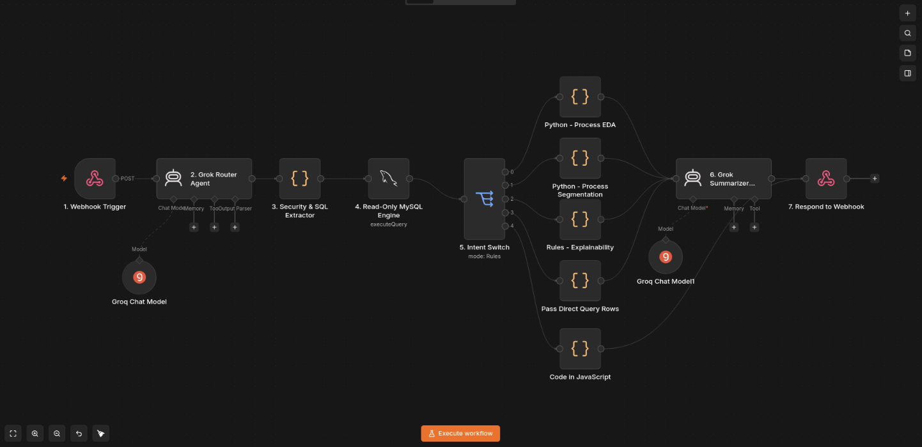
Pipeline — Node by Node
# | Node | Job
1 | Webhook Trigger | Receives the user's natural-language query over POST.
2 | Grok Router Agent | Classifies intent (DIRECT_QUERY, EDA, EXPLAINABILITY, SEGMENTATION, UNSUPPORTED) and writes the exact SQL needed.
3 | Security & SQL Extractor | Parses the router's JSON, strips markdown, and blocks any write-operation SQL (DROP/DELETE/UPDATE/etc.). Degrades gracefully to UNSUPPORTED instead of crashing on malformed output.
4 | Read-Only MySQL Engine | Executes the generated SELECT against cc_general.
5 | Intent Switch | Routes the raw SQL result to one of 5 branches based on intent.
6a–6d | Intent Filter Nodes | Trim/round/prune the raw rows to only what's needed (see Token Optimization).
7 | Grok Summarizer Agent | Turns the filtered data into a plain-language answer, tailored per intent.
8 | Respond to Webhook | Returns { summary, intent, data } as JSON.

Note: Why route first instead of one big prompt? A single AI call reasoning over all 18 columns and writing the final answer in one shot is slow, expensive and error-prone. Splitting it into route → execute → filter → summarize means each call has one narrow job and only sees the data it needs.
How Intent Is Decided
Intent | Trigger Rule | Example
DIRECT_QUERY | Ordered records, rankings, limits, filtered lists (always takes priority over EDA). | "Top 5 customers by purchases"
EDA | Portfolio-level stats — averages, totals, counts (not a ranked list). | "Average credit limit?"
EXPLAINABILITY | Targets a specific customer ID. | "Audit customer C10012"
SEGMENTATION | Divide/group the portfolio into personas. | "Segment the portfolio"
UNSUPPORTED | Outside the dataset, or a write-operation attempt. | "Delete table cc_general"

3. Security & Safety — Preventing Harmful Queries
Because the AI router writes its own SQL, there's a real risk a user could ask the system to modify or destroy data — e.g. "delete all customers" or "update everyone's balance to zero." TRÉSOR is built to make this impossible, not just unlikely:
- Blocked at the source, not after the fact — Every SQL statement produced by the Router passes through a dedicated Security & SQL Extractor node before it goes anywhere near the database.
- Keyword-level filtering — The extractor explicitly scans for and rejects write-operation keywords: DROP, DELETE, UPDATE, INSERT, ALTER, TRUNCATE.
- Read-only database engine — The database connection itself is read-only, so even if something slipped through, the DB user has no permission to execute it.
- Graceful degradation — If the AI router ever produces malformed or unexpected output, the pipeline doesn't crash — it falls back to UNSUPPORTED.
- Fixed, predictable fallback — Any destructive or out-of-scope query is instantly classified UNSUPPORTED and answered with a fixed, safe refusal — zero downstream AI cost.
Safe by Design, Dynamic by Nature
TRÉSOR is dynamic in how it understands questions — it handles rankings, averages, audits and segmentation phrased almost any casual way, with no hard-coded sentences. But it is deliberately rigid about data safety:
- We are dynamic in language understanding, but rigid and predictable in data protection.
- The AI decides how to answer a question — never whether it's allowed to write, update, or delete data. That decision is hard-coded and cannot be talked around by clever phrasing.
- This makes it safe to expose to non-technical staff, or even careless/malicious input, with zero risk to the underlying database.
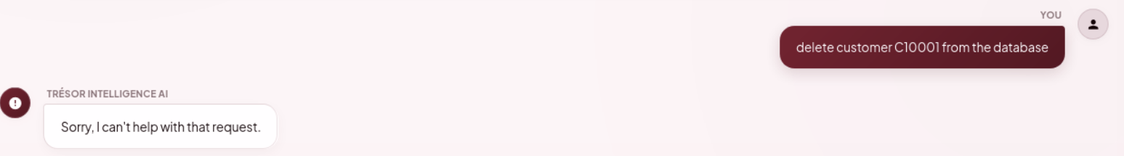

4. User Interface
TRÉSOR's front end is a single-page chat application — one conversation window plus a sidebar of shortcuts and history, so there's no dashboard to learn.
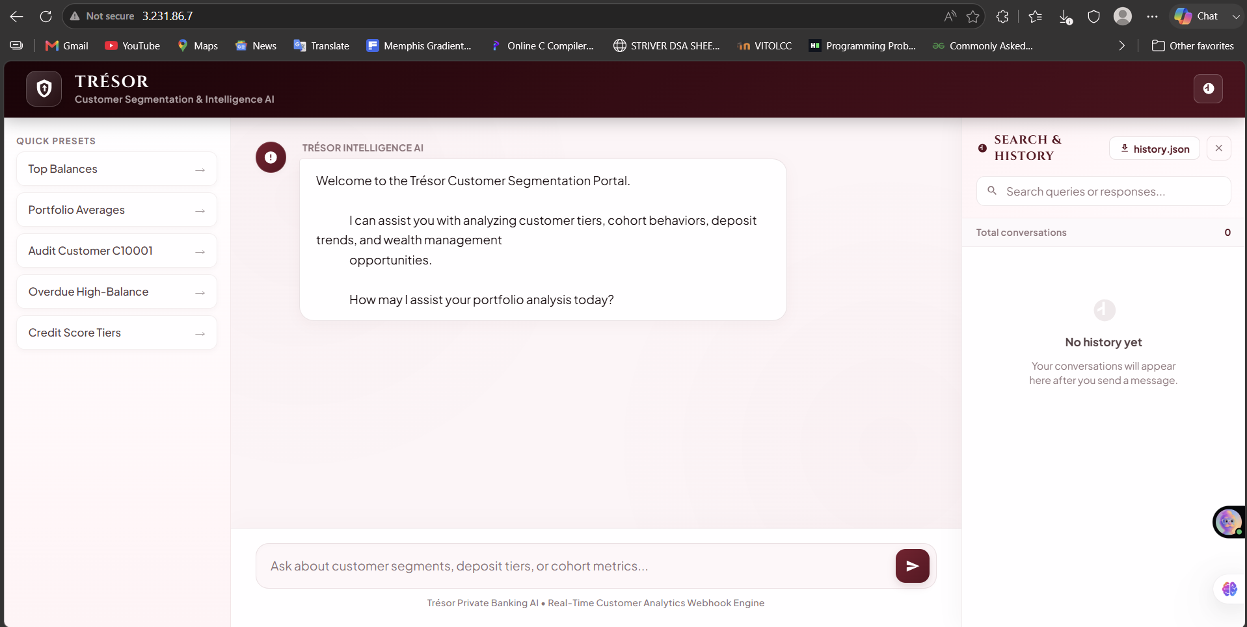
Shows the complete interface: a Quick Presets panel on the left for one-click common questions, the main chat window in the center, and a searchable Search & History panel on the right.
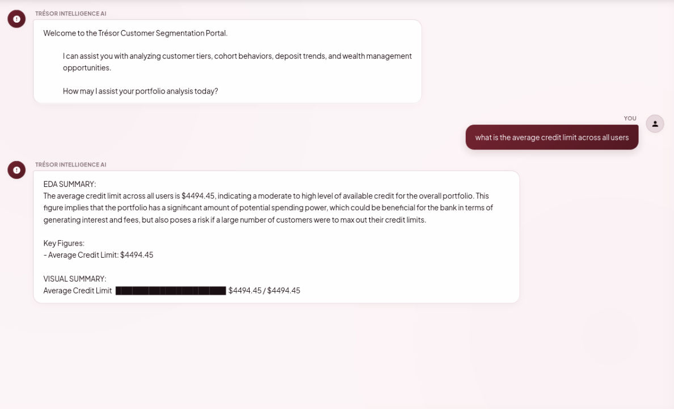

Shows an EDA-intent answer: a plain-English summary, key figures, and a visual bar summary.
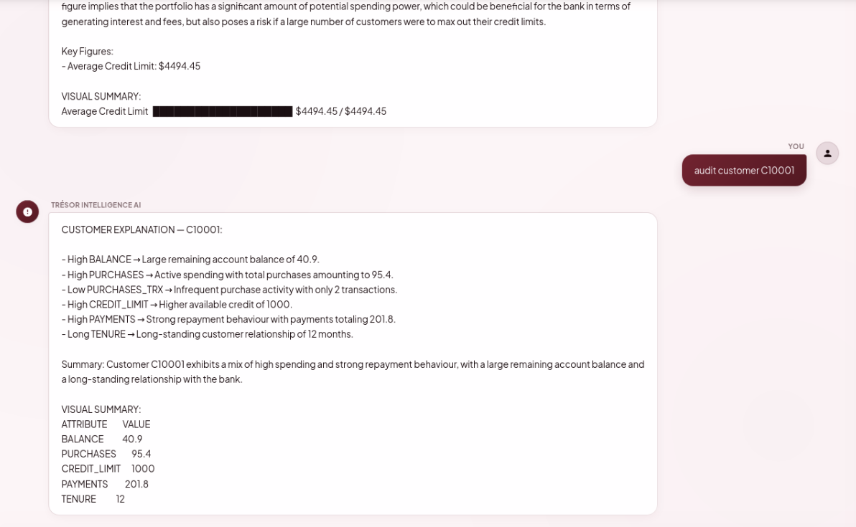Shows a single customer's attribute-by-attribute explanation (e.g. High BALANCE → ..., Long TENURE → ...), plus a value table.
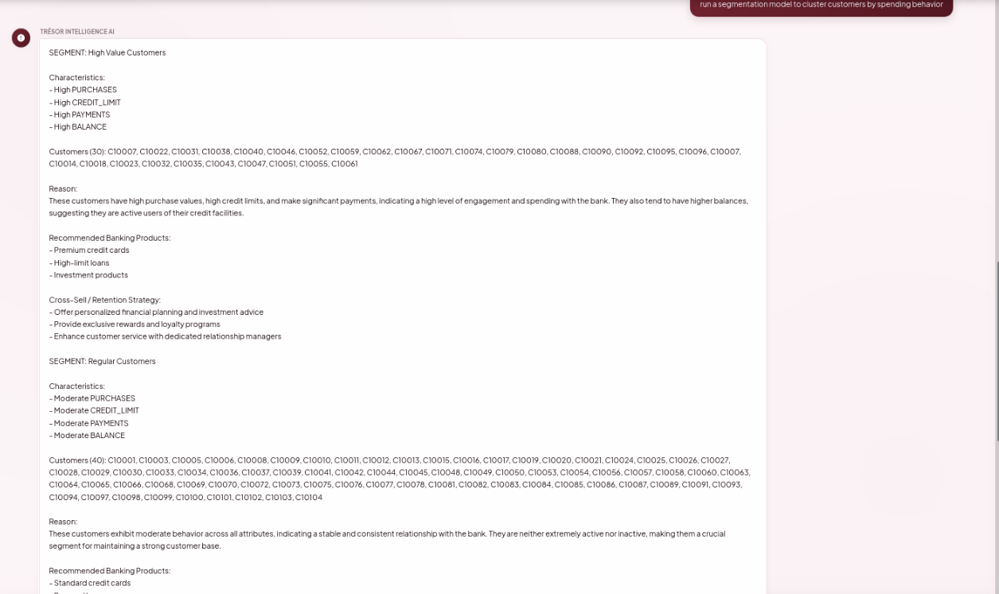
Shows named personas (e.g. High Value Customers) with characteristics, customer IDs, reasoning, recommended products, and a cross-sell strategy.

5. Deployment
Deployed with a single command on any Docker-enabled machine — no manual UI clicking or credential wiring needed:
- Clone the repo, copy .env.example to .env.
- Generate an n8n encryption key: openssl rand -hex 32, paste into .env.
- Fill in DB credentials, WEBHOOK_URL (server IP), and GROQ_API_KEY.
- Run: docker compose up -d
Tech Stack
Layer | Technology
Frontend | HTML / CSS / Vanilla JavaScript
Reverse Proxy | nginx
Orchestration | n8n (self-hosted, open-source)
LLM | Groq API (Llama 3)
Database | MySQL 8
Deployment | Docker Compose

6. Why This Architecture Works
- Fast — each AI call is narrow-scoped (route, then summarize); no call reasons over the full dataset.
- Efficient — intent-based filtering means every response pays only for the tokens it needs; UNSUPPORTED skips the summarizer entirely.
- Dynamic — one pipeline handles rankings, aggregates, audits, and segmentation from a single natural-language entry point.
- Safe by Construction — write-operation SQL is blocked before execution; malformed output degrades gracefully; unsupported requests get a fixed response.
- Reproducible — the entire stack comes up identically from one command, on any machine.
One command to deploy. One chat box to query. Five intents, fully explainable, and safe by construction — that's TRÉSOR.

